<https://github.com/keatonarneson/SpringBoot/tree/main/FinalProject>

COMMENTS

* I focused on general functionality on each of the end points for how I wanted the api to behave.
* Smaller details (e.g. few bugs in exceptions) and bigger details that I assumed were out of scope of the project (e.g. password encryption) were sacrificed for what I believe was the project scope.
* Improvements/oversights would be greater control of my return objects (e.g. remove password from return User object). It would entail more Entities that I believed were out of the project scope based on the amount of end points I decided to create. Another example is when a User follows another User, it would only return the necessary User data needed to fill in the following page on the client side. An alternative is to use @JsonIgnore, but that felt lacking in some regards.
* Future additions to the project would be password encryption and authorization.
* There was no submission document, and the example I was given wouldn’t open, so I hope this submission is sufficient. I would be happy to supplement this document and github for anything else that I missed. I would also be happy to answer any questions about it as well. Thanks

Keaton Arneson

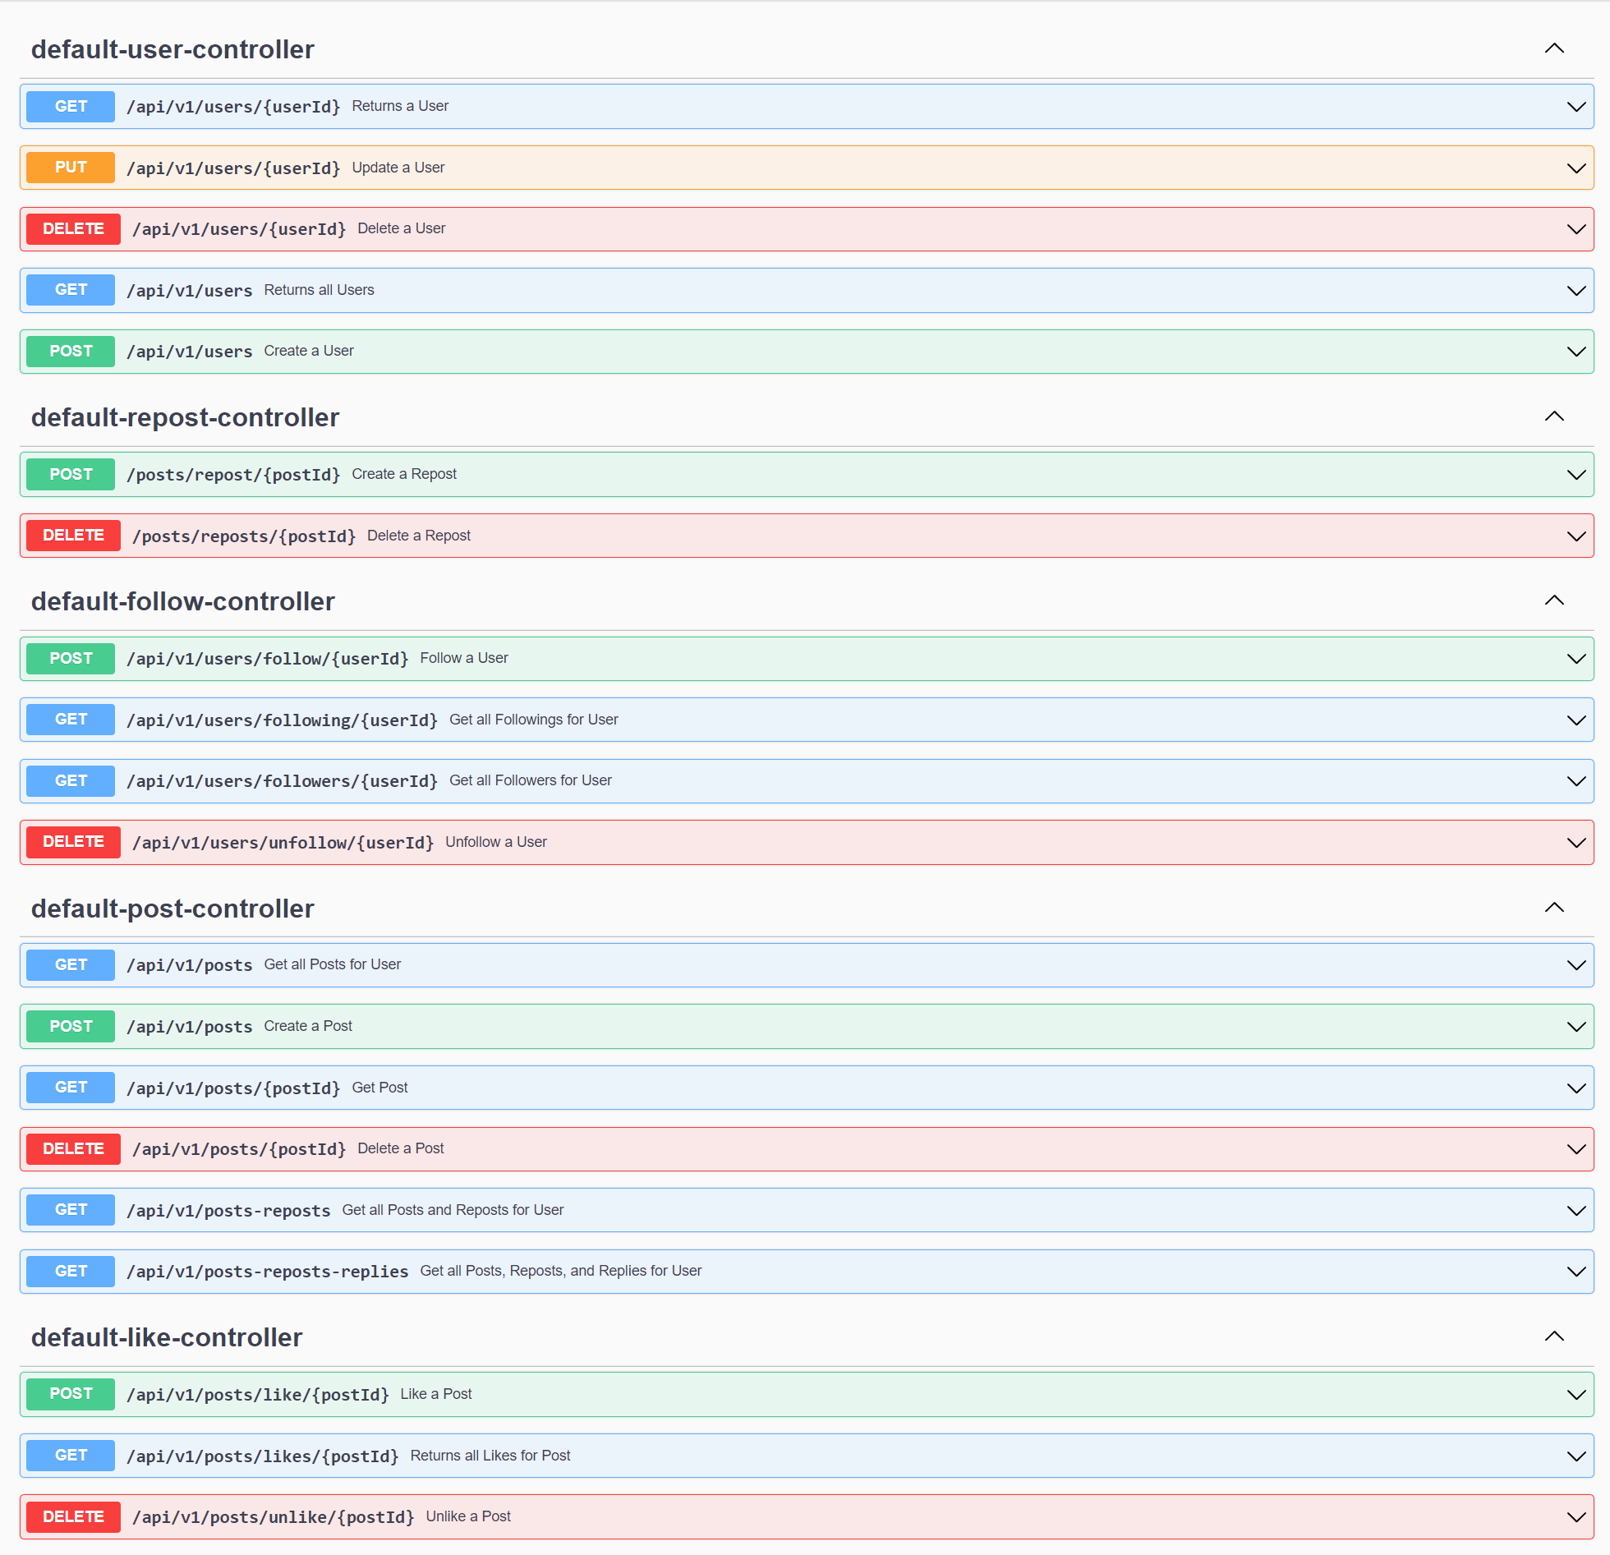

USER CONTROLLER

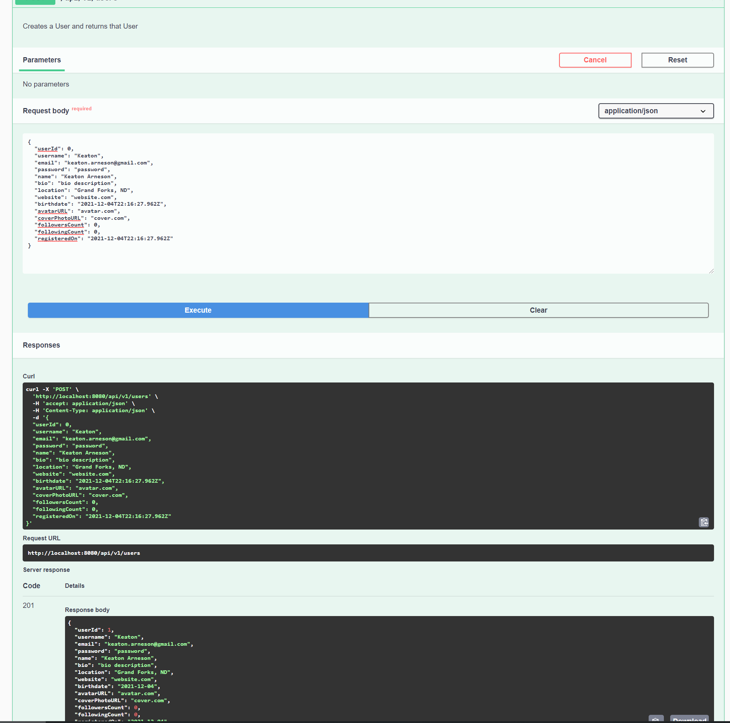

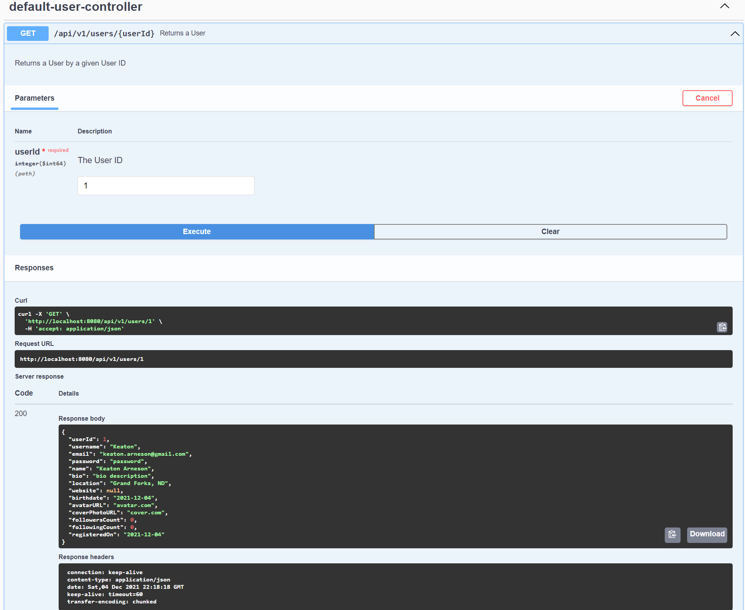

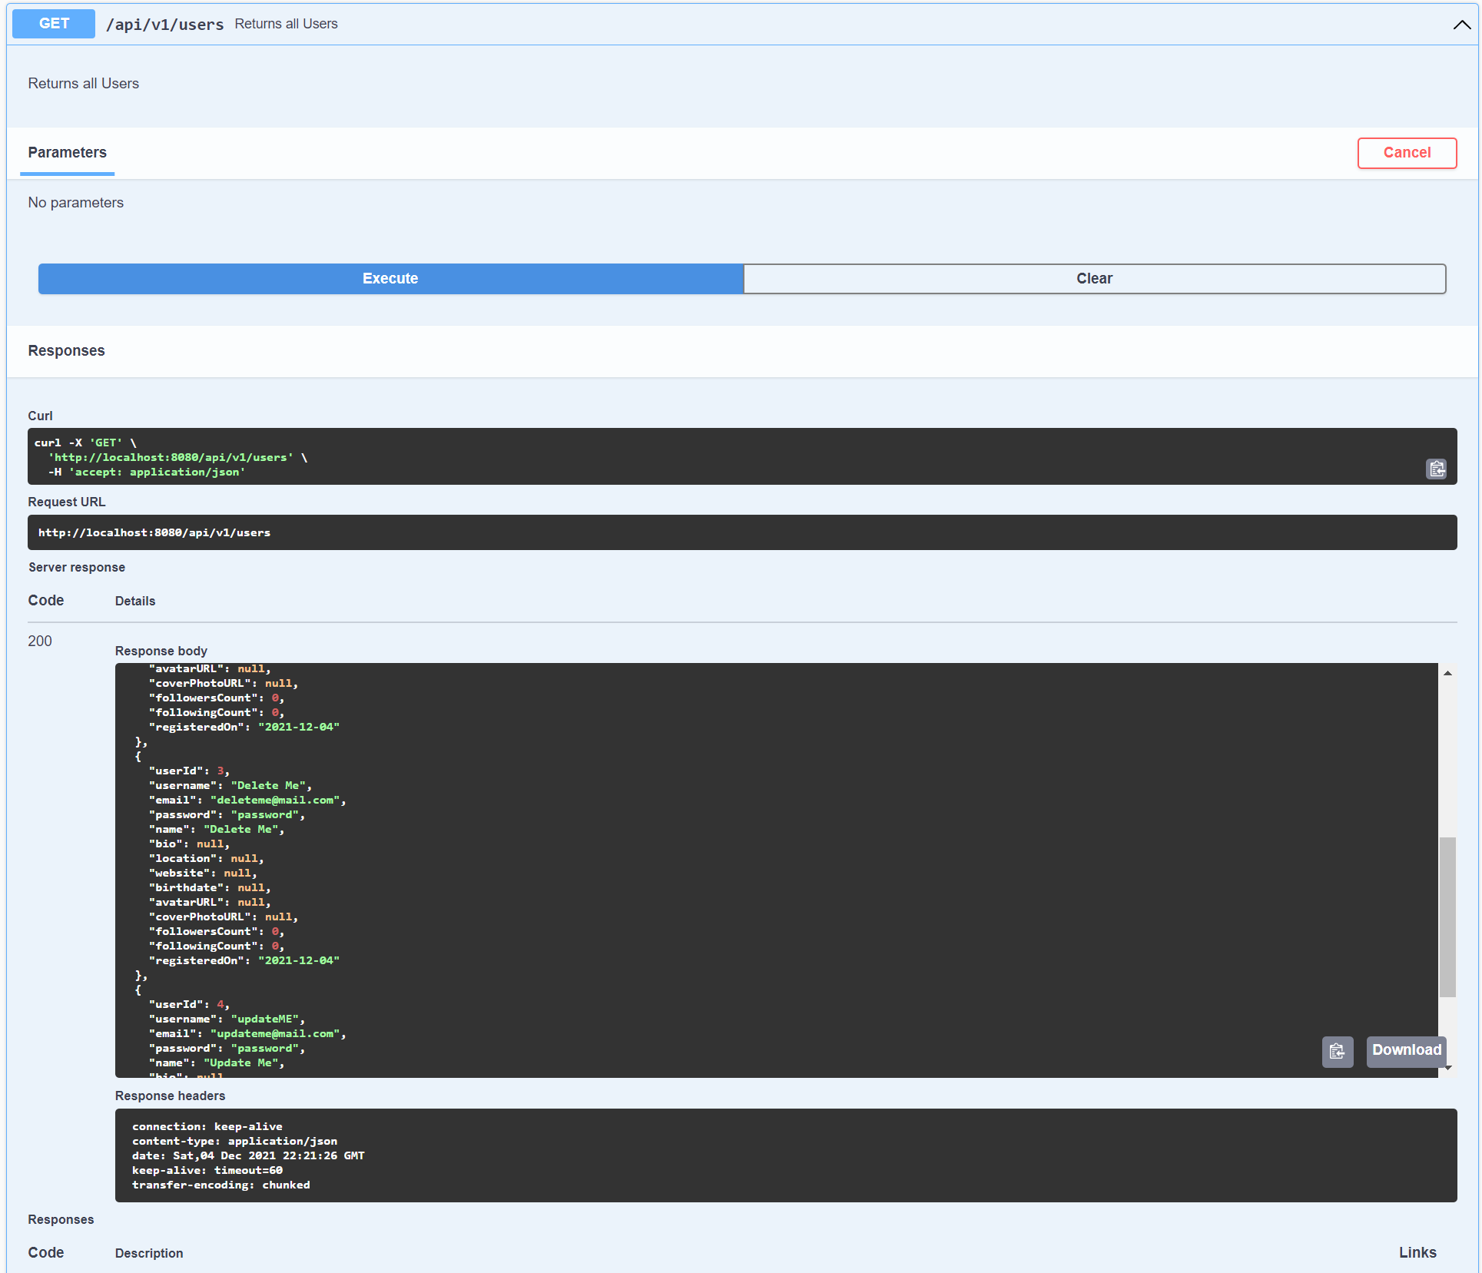

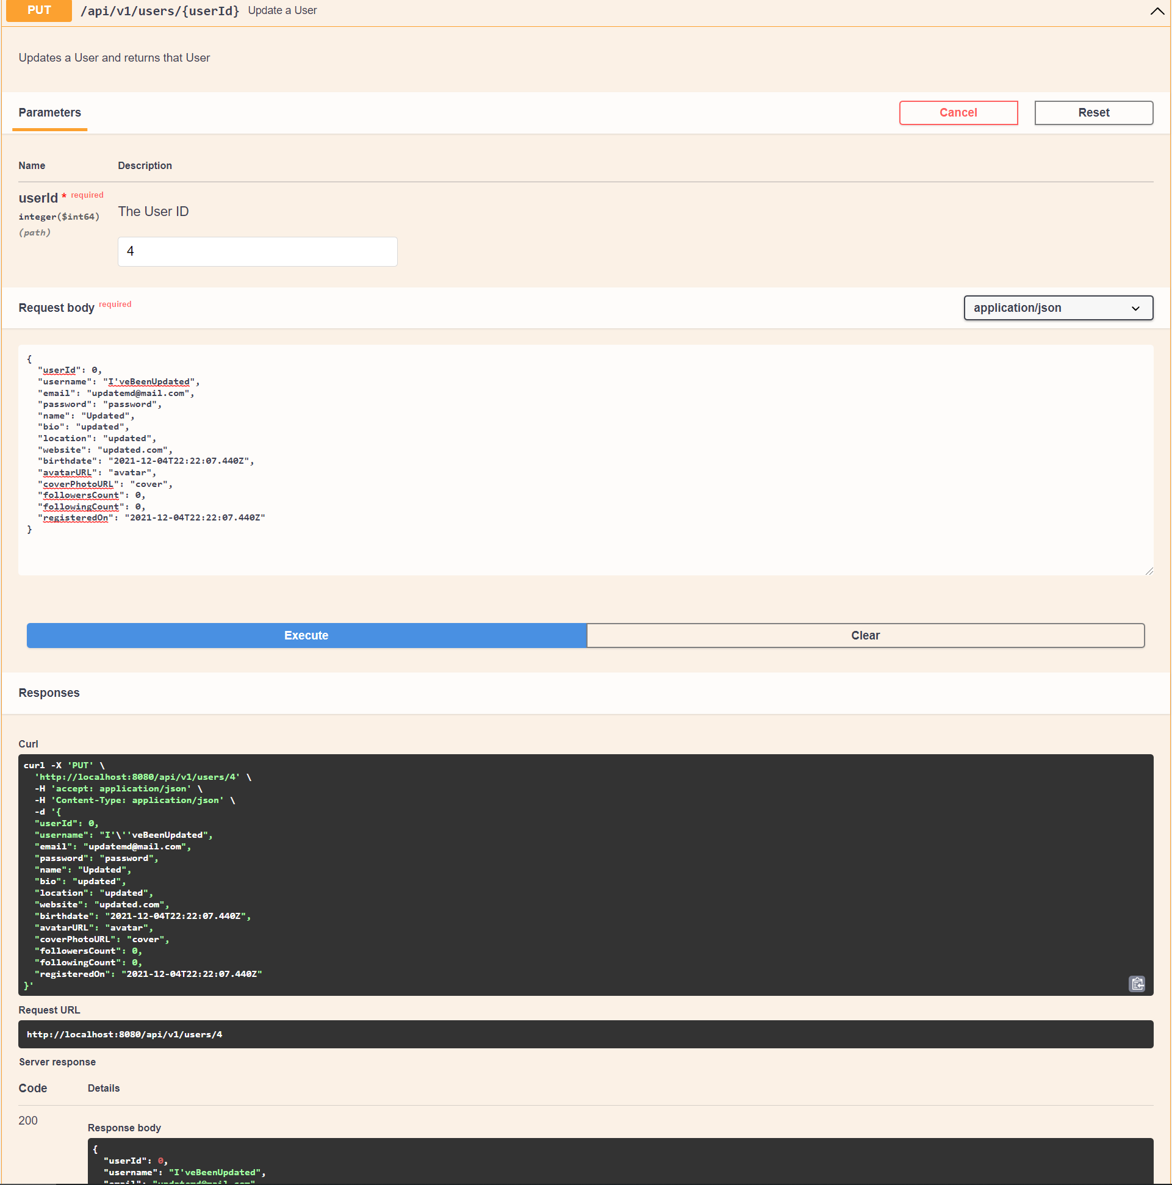

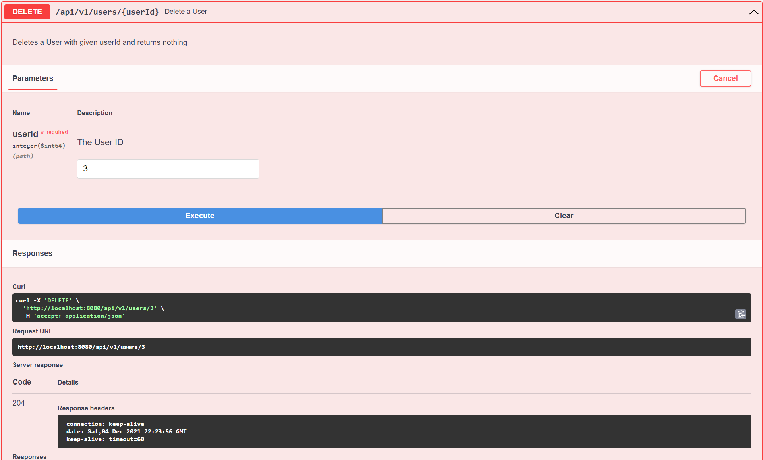

POST CONTROLLER

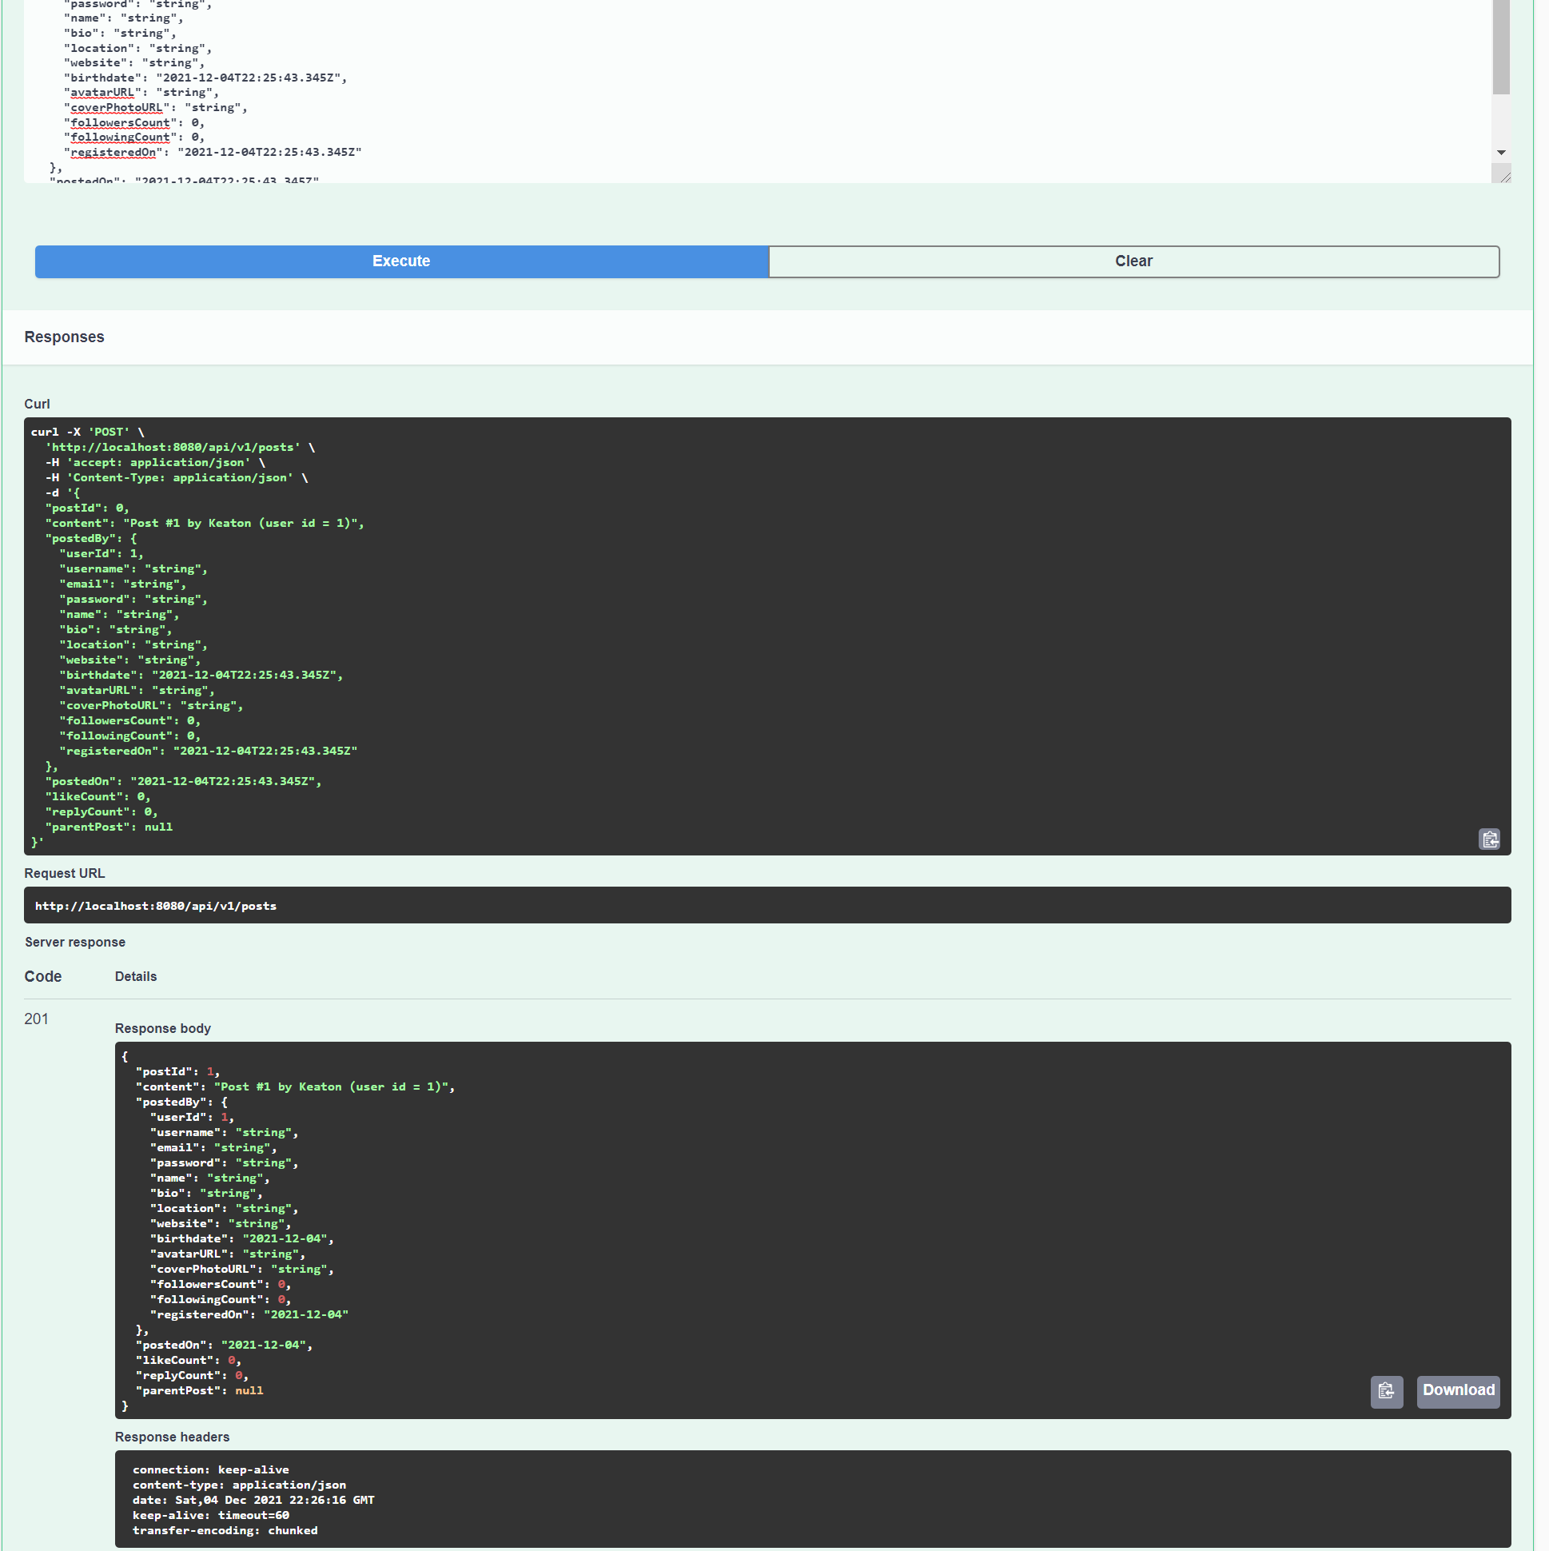

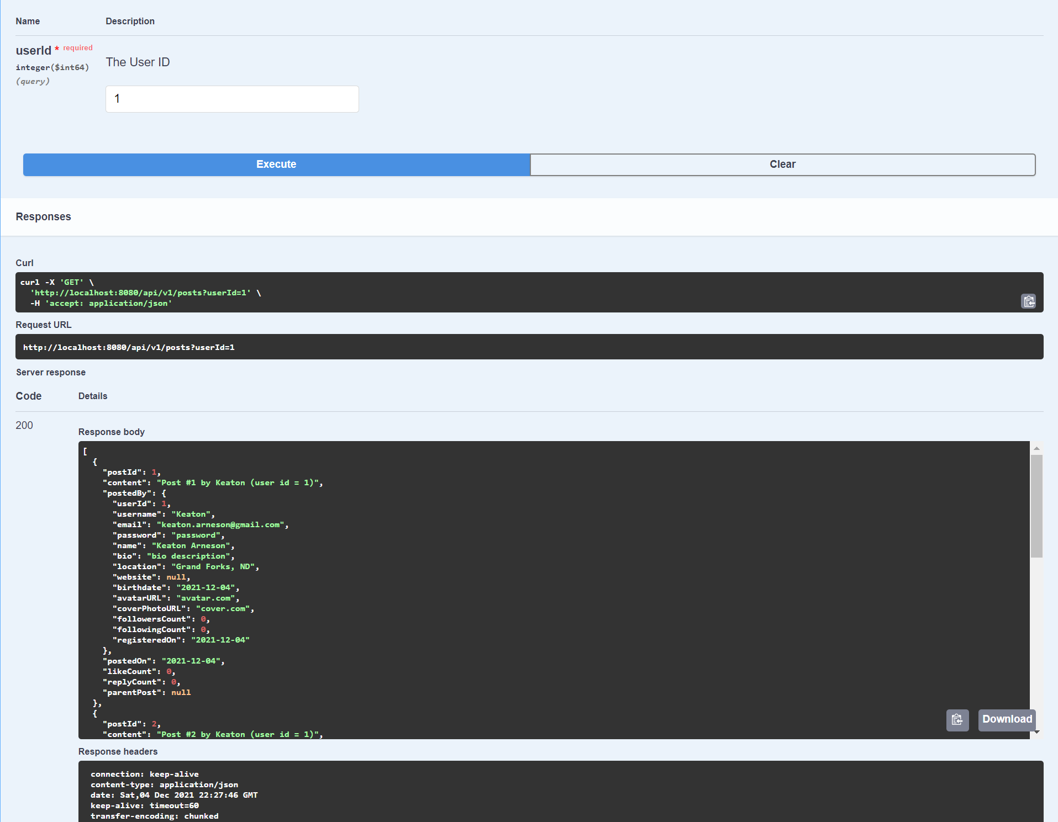

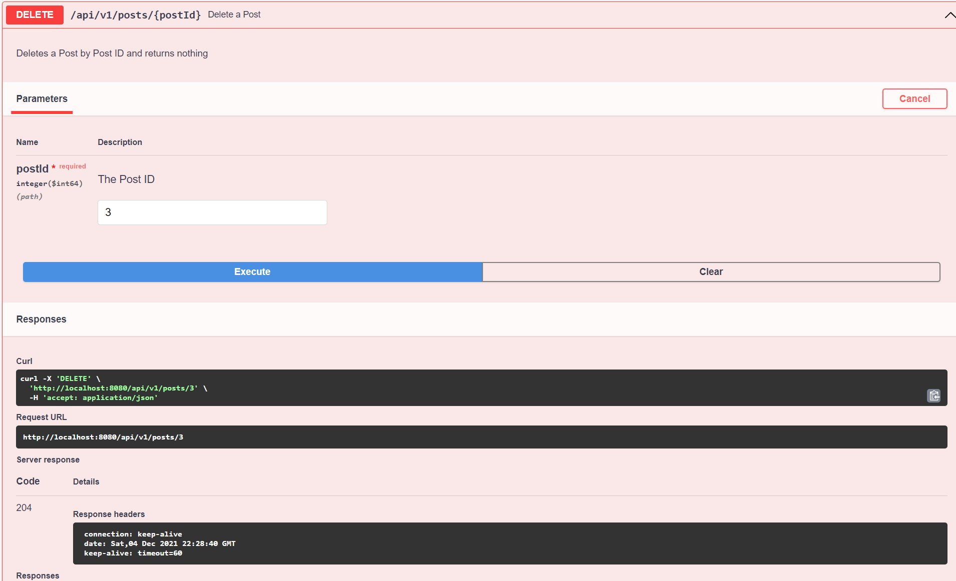

LIKE CONTROLLER

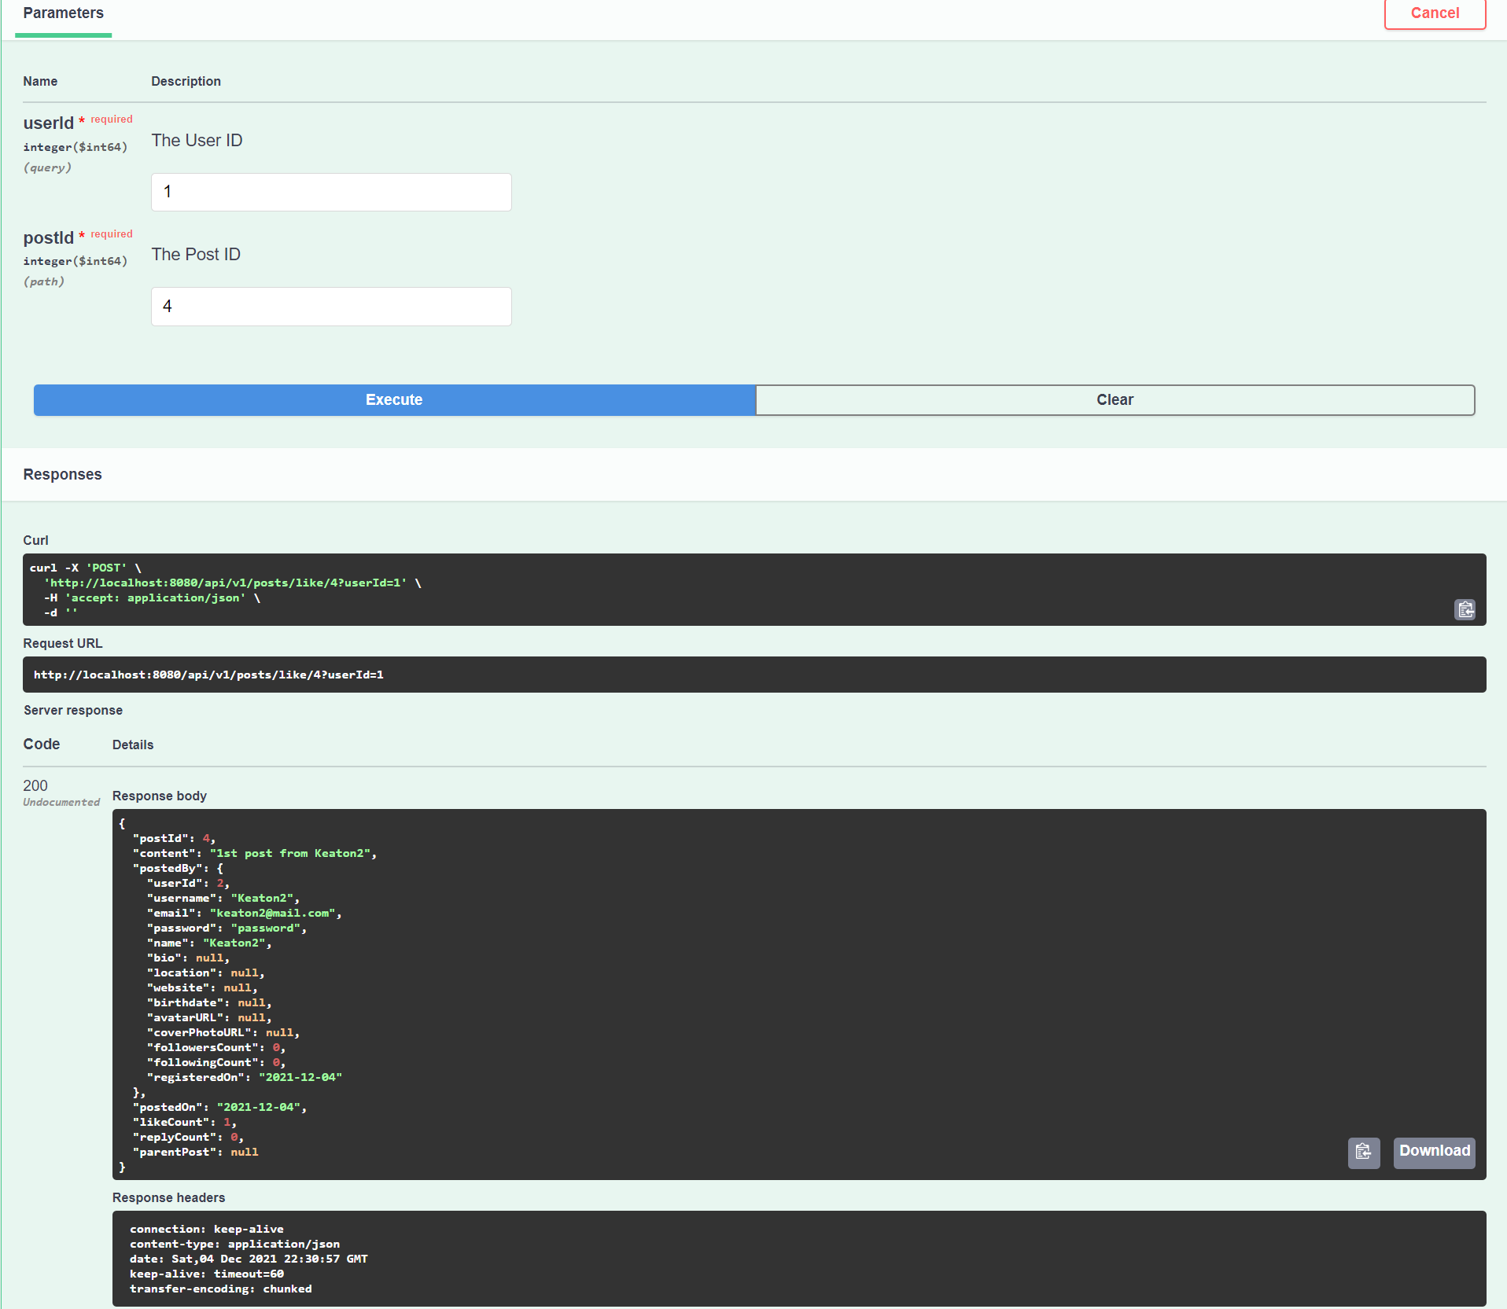

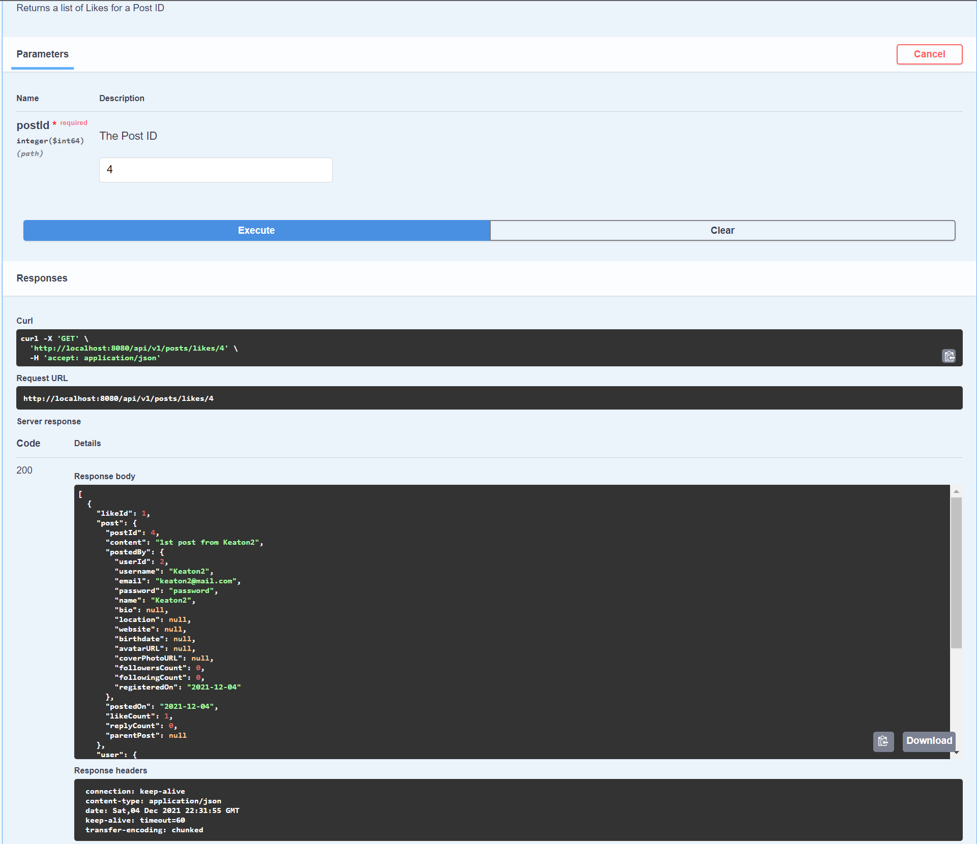

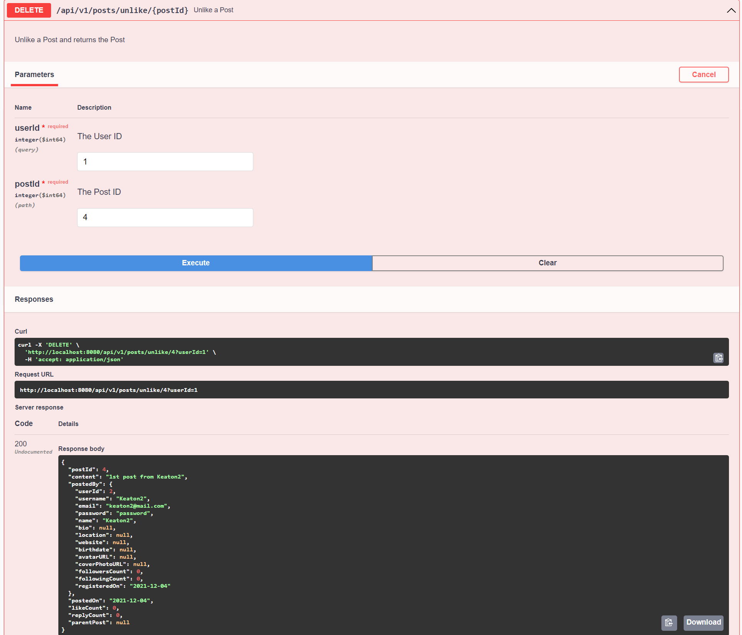

REPOST CONTROLLER

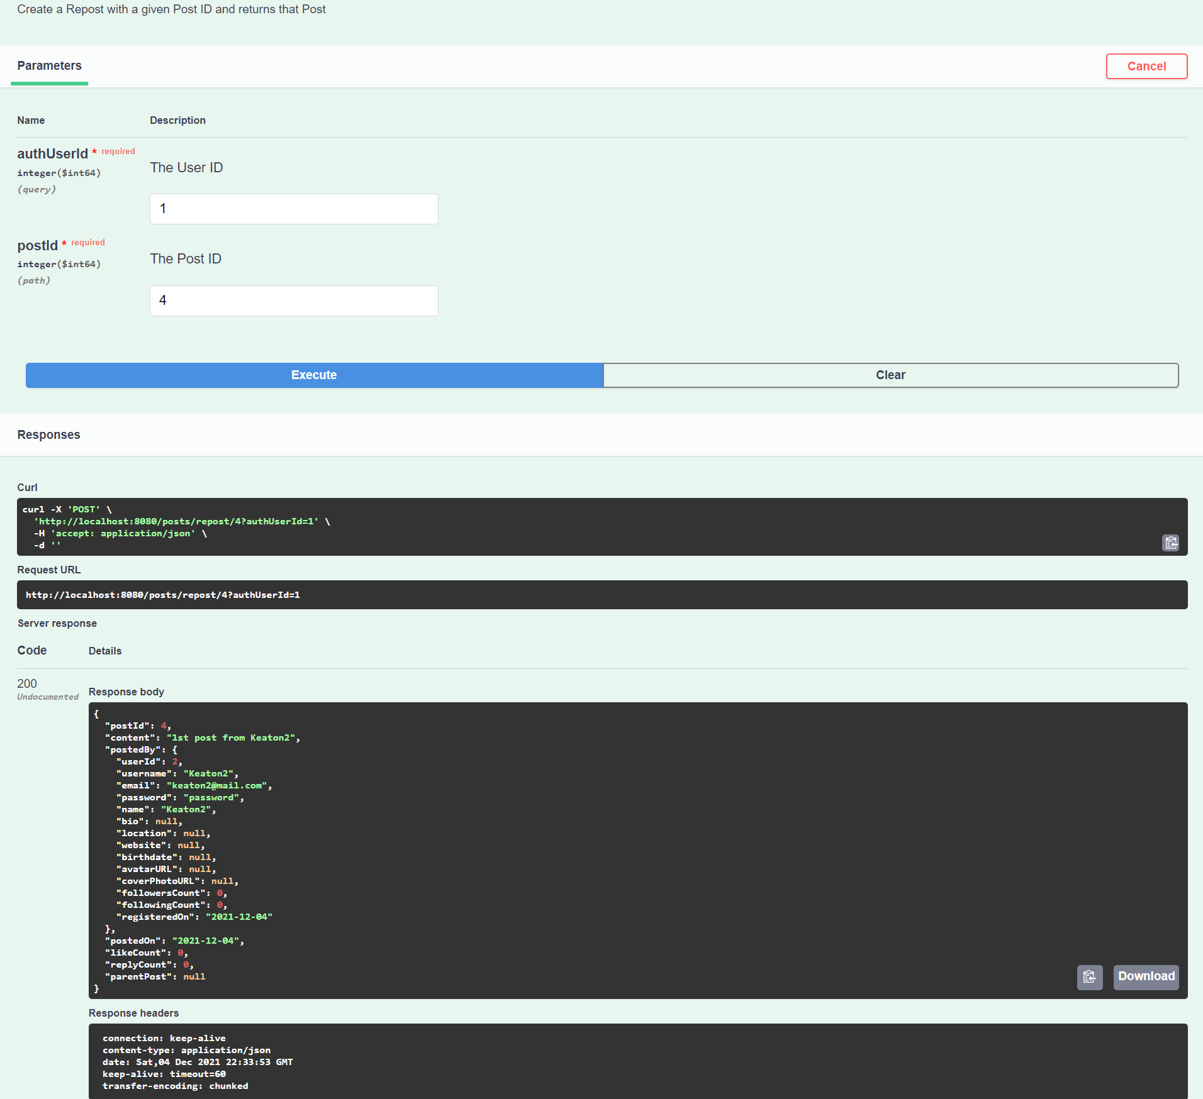

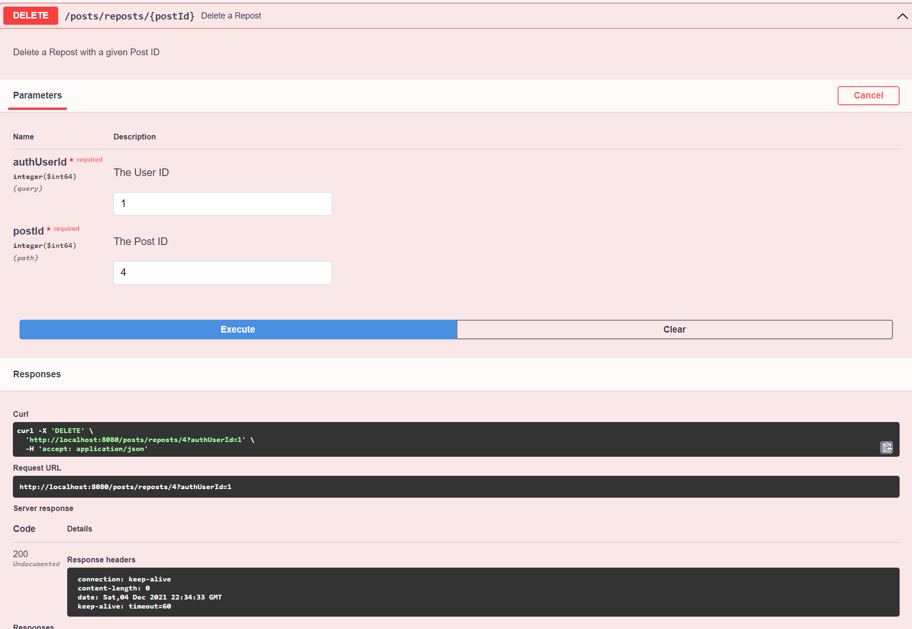

FOLLOW CONTROLLER

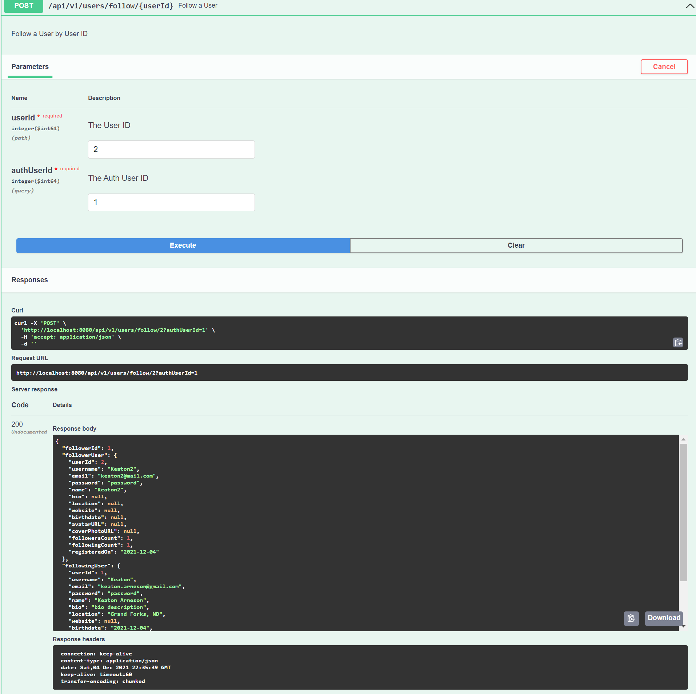

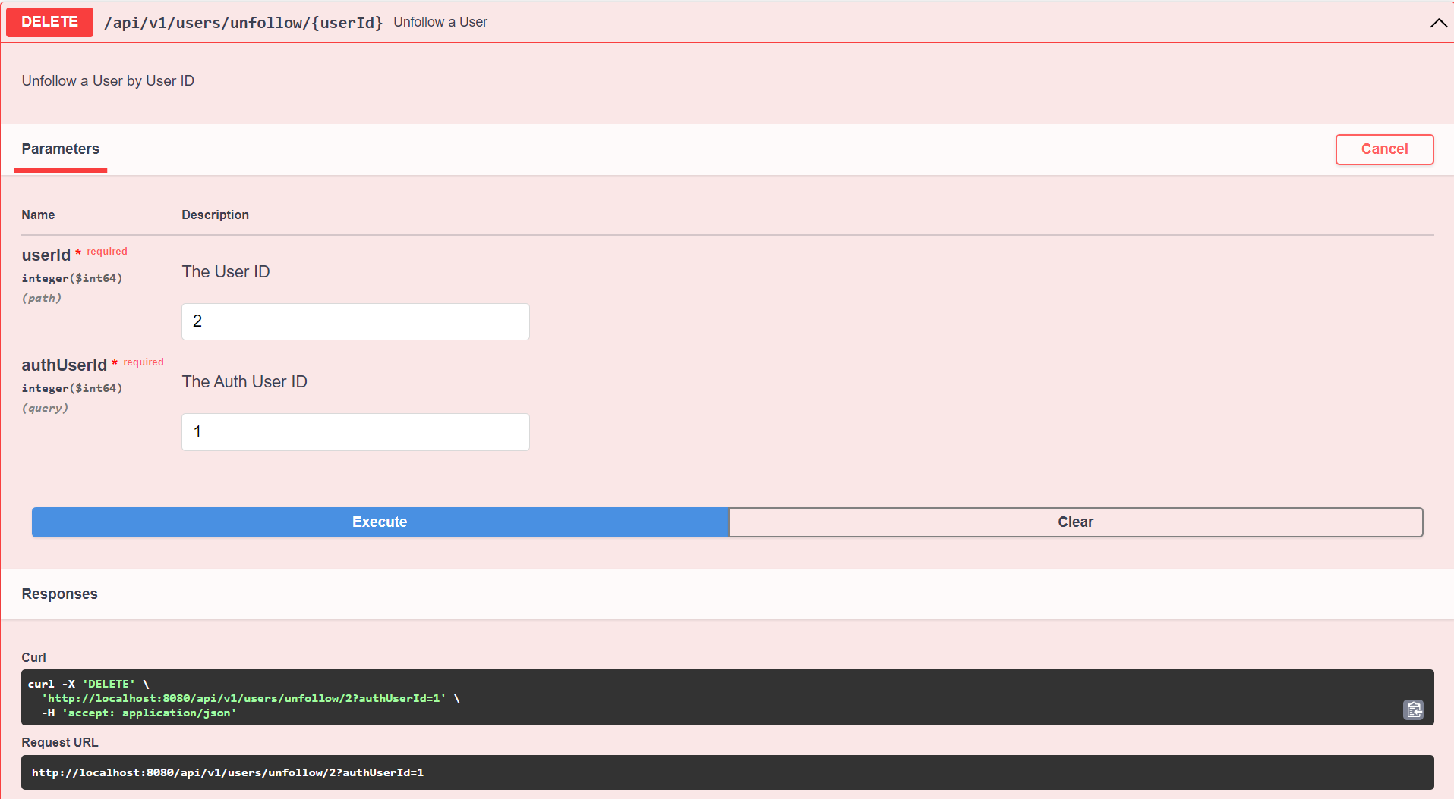

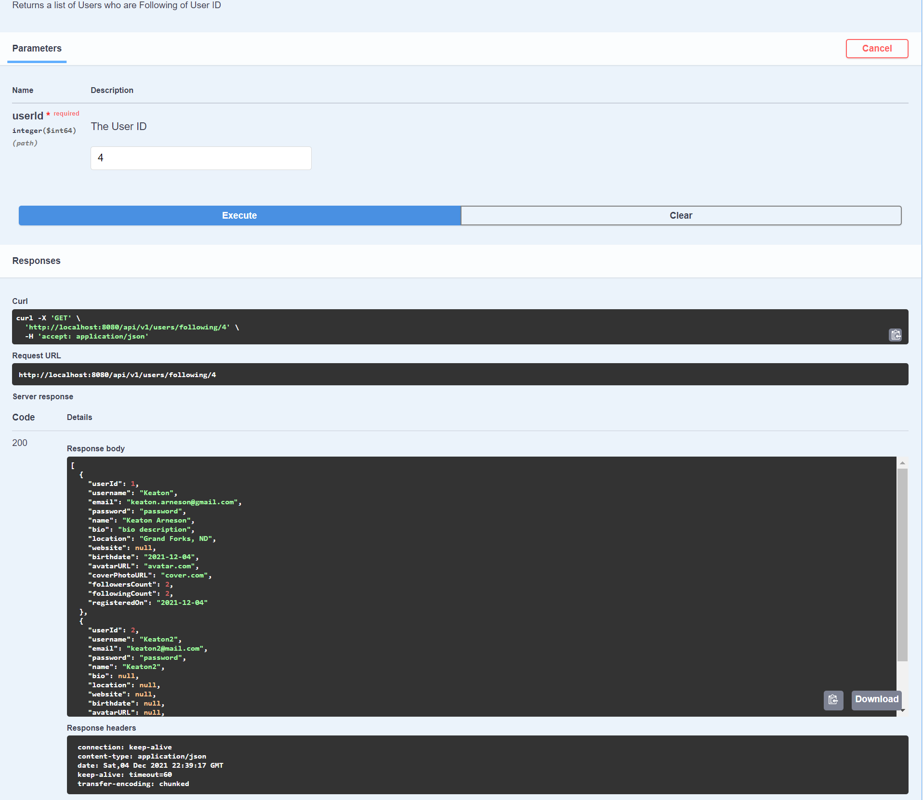

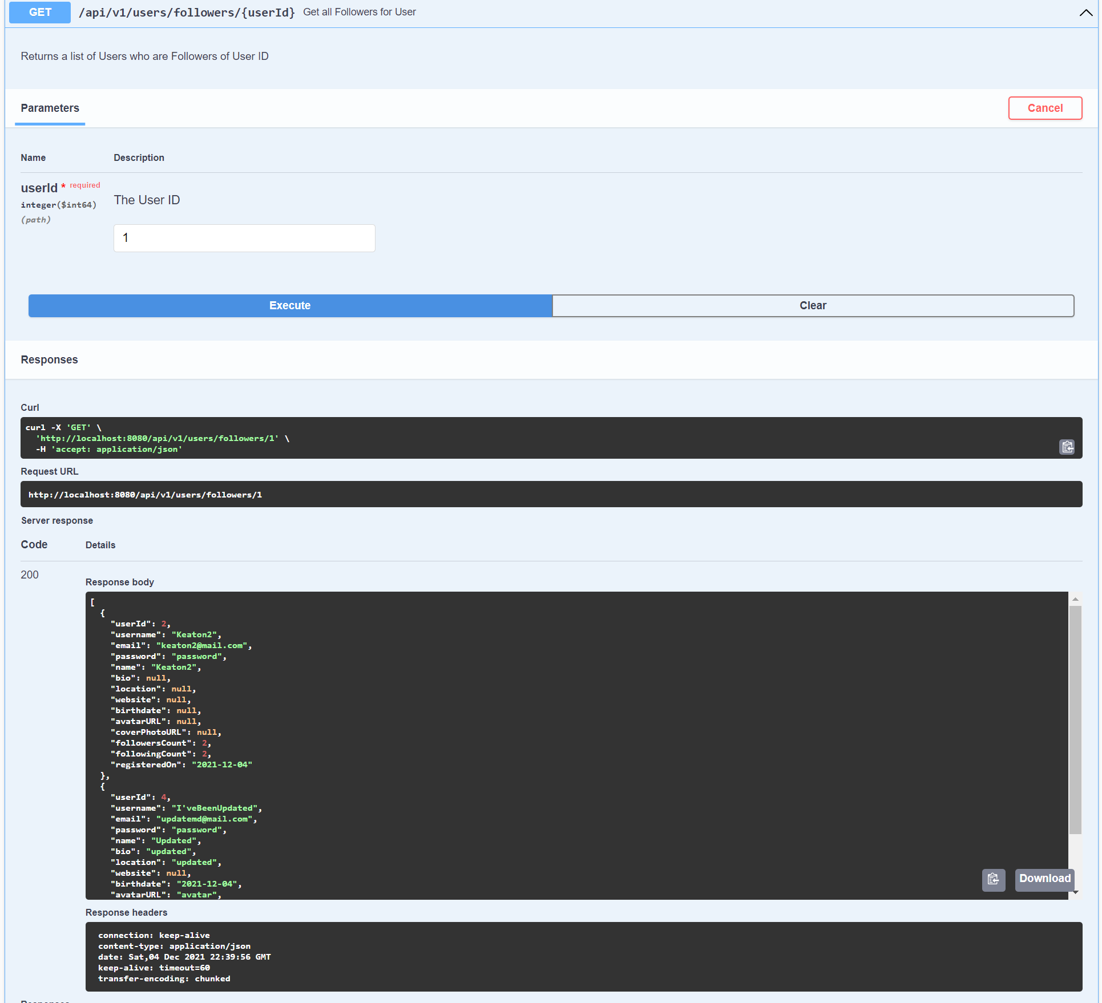

POST CONTROLLER WITH REPOSTS AND REPLIES

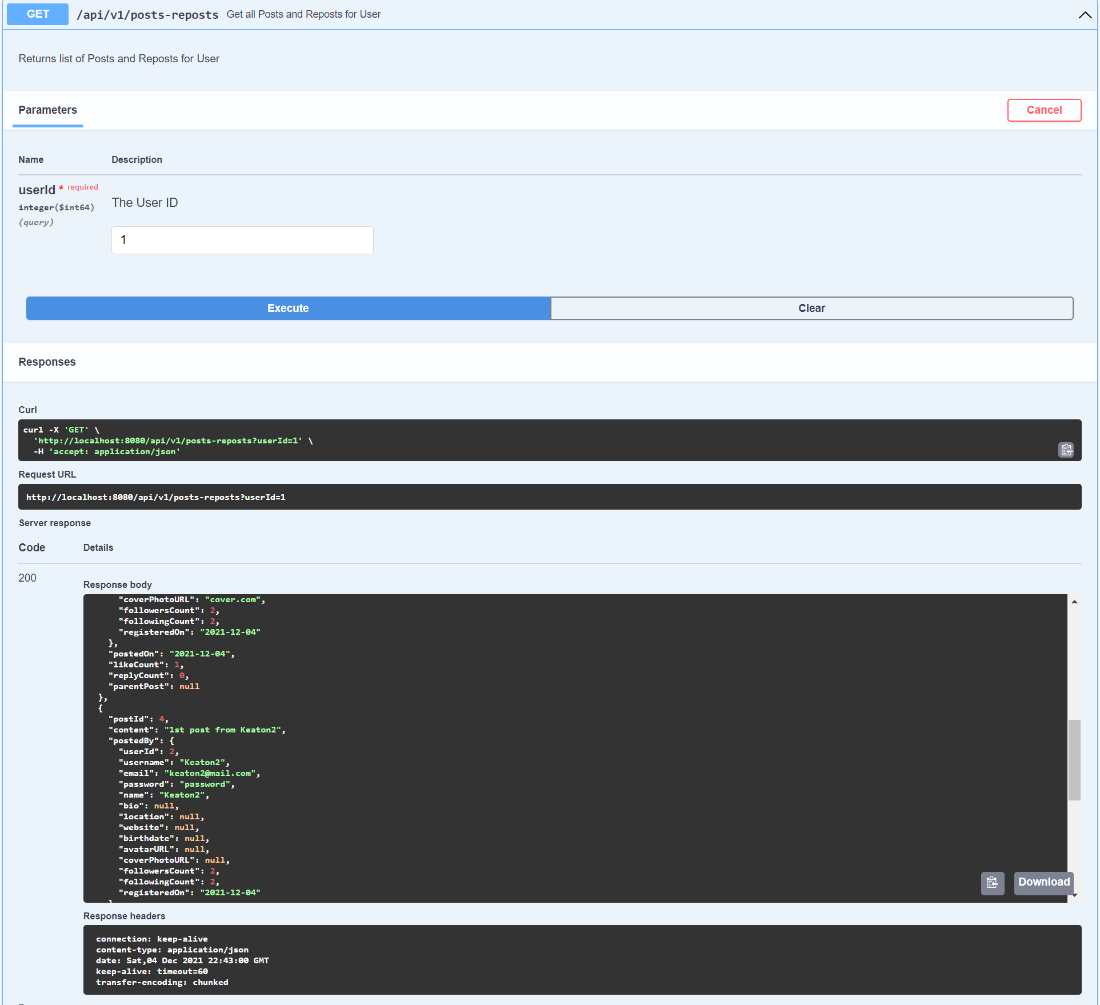

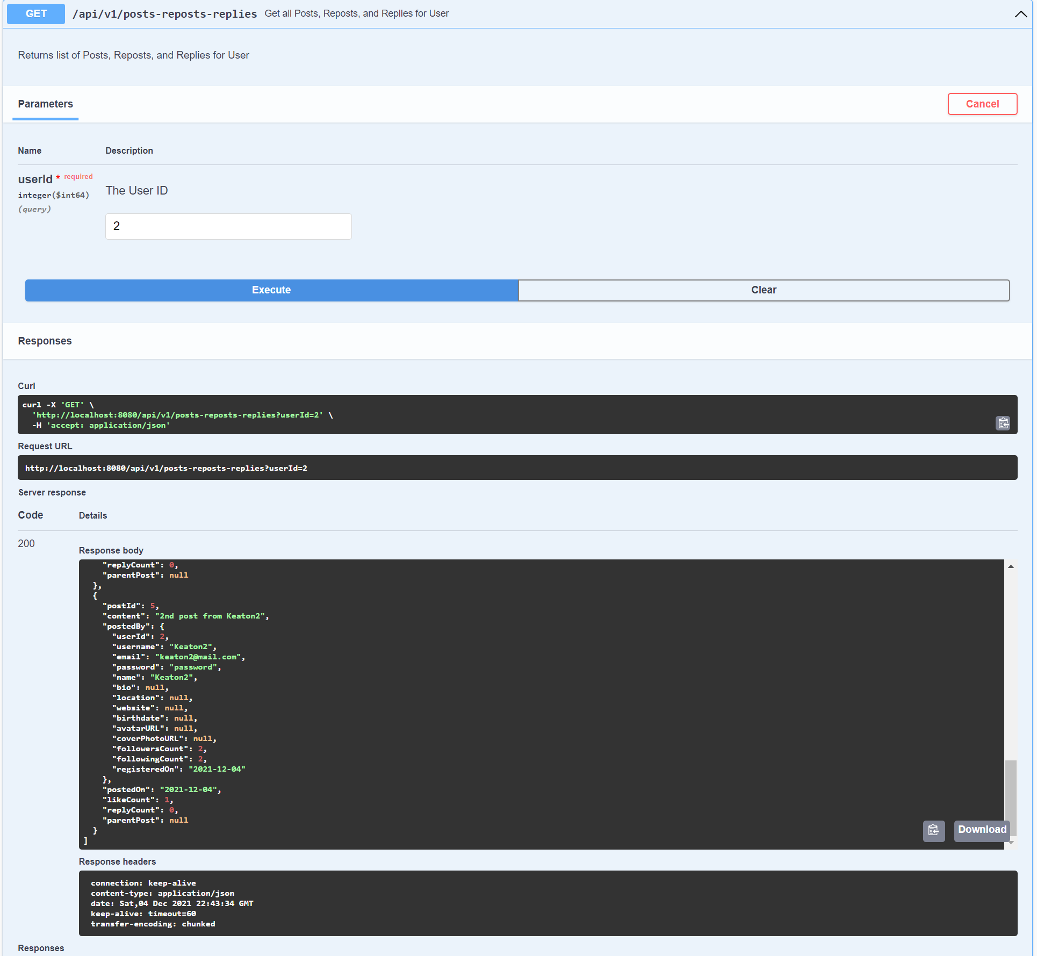

EXCEPTIONS

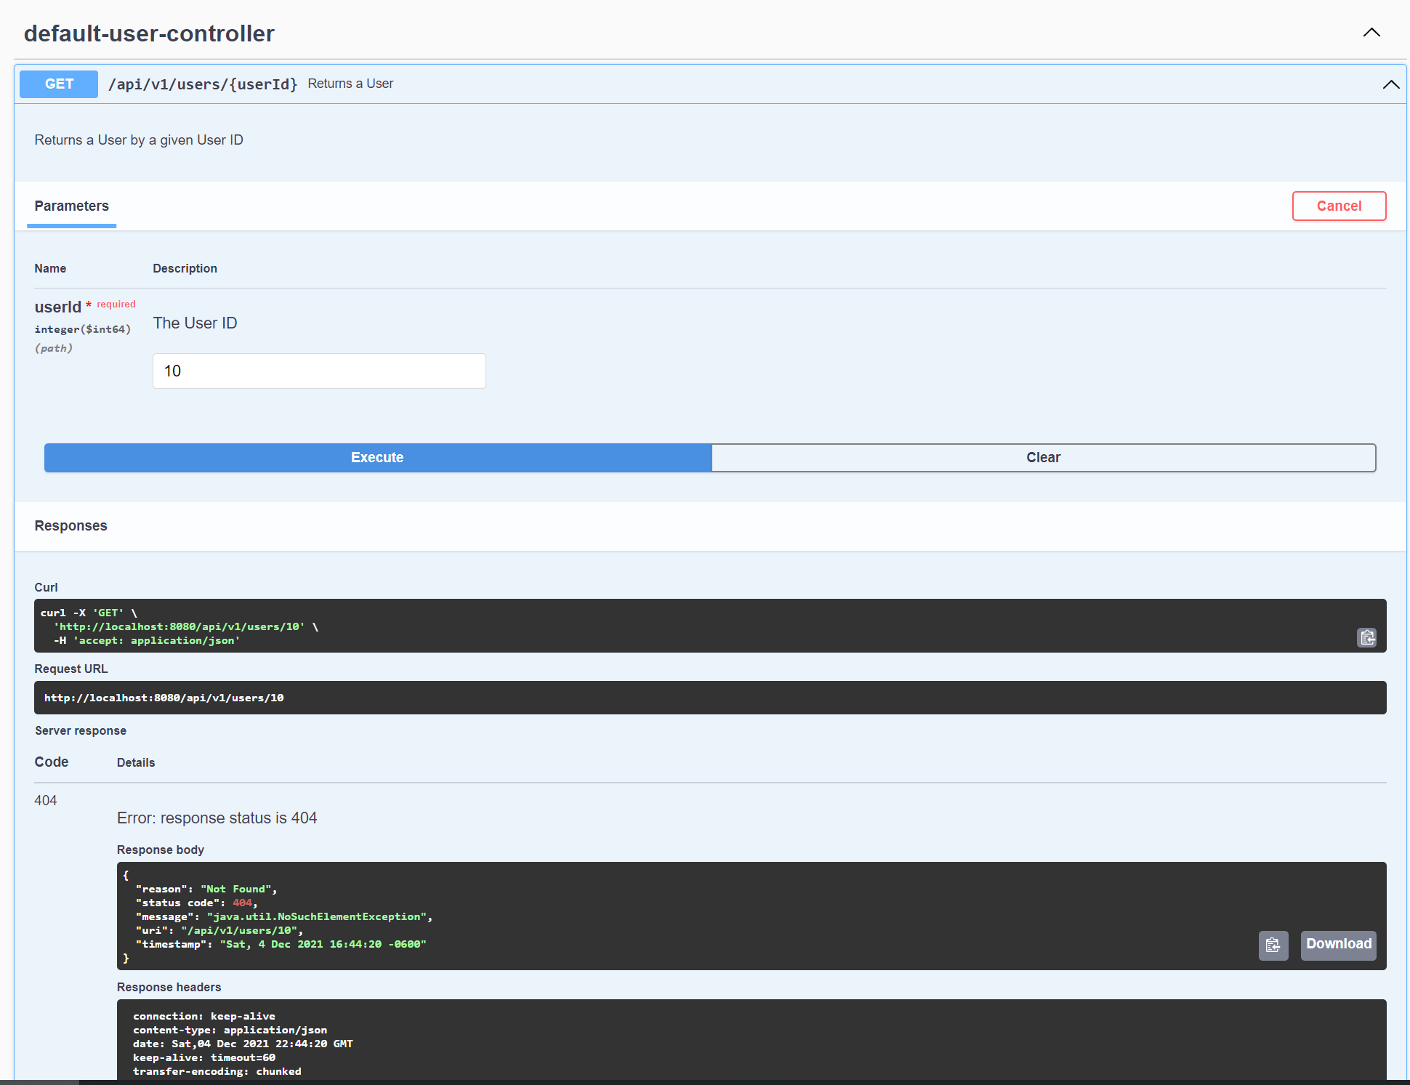

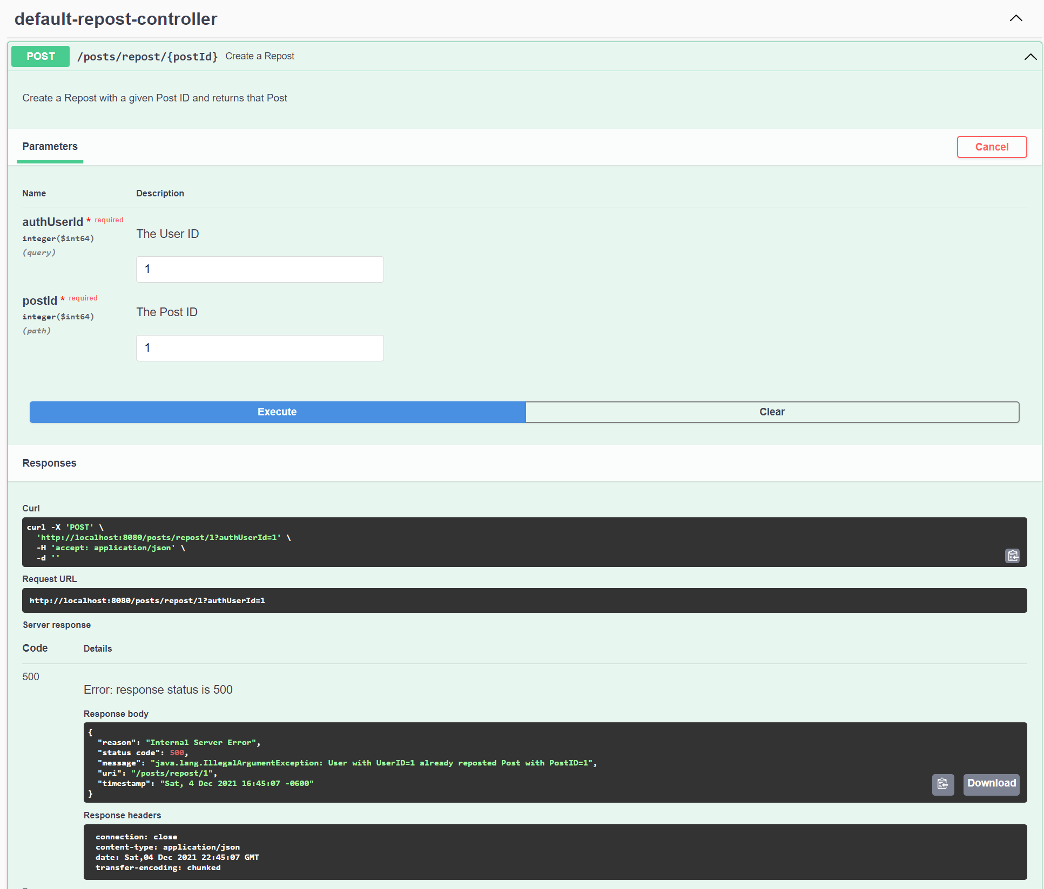

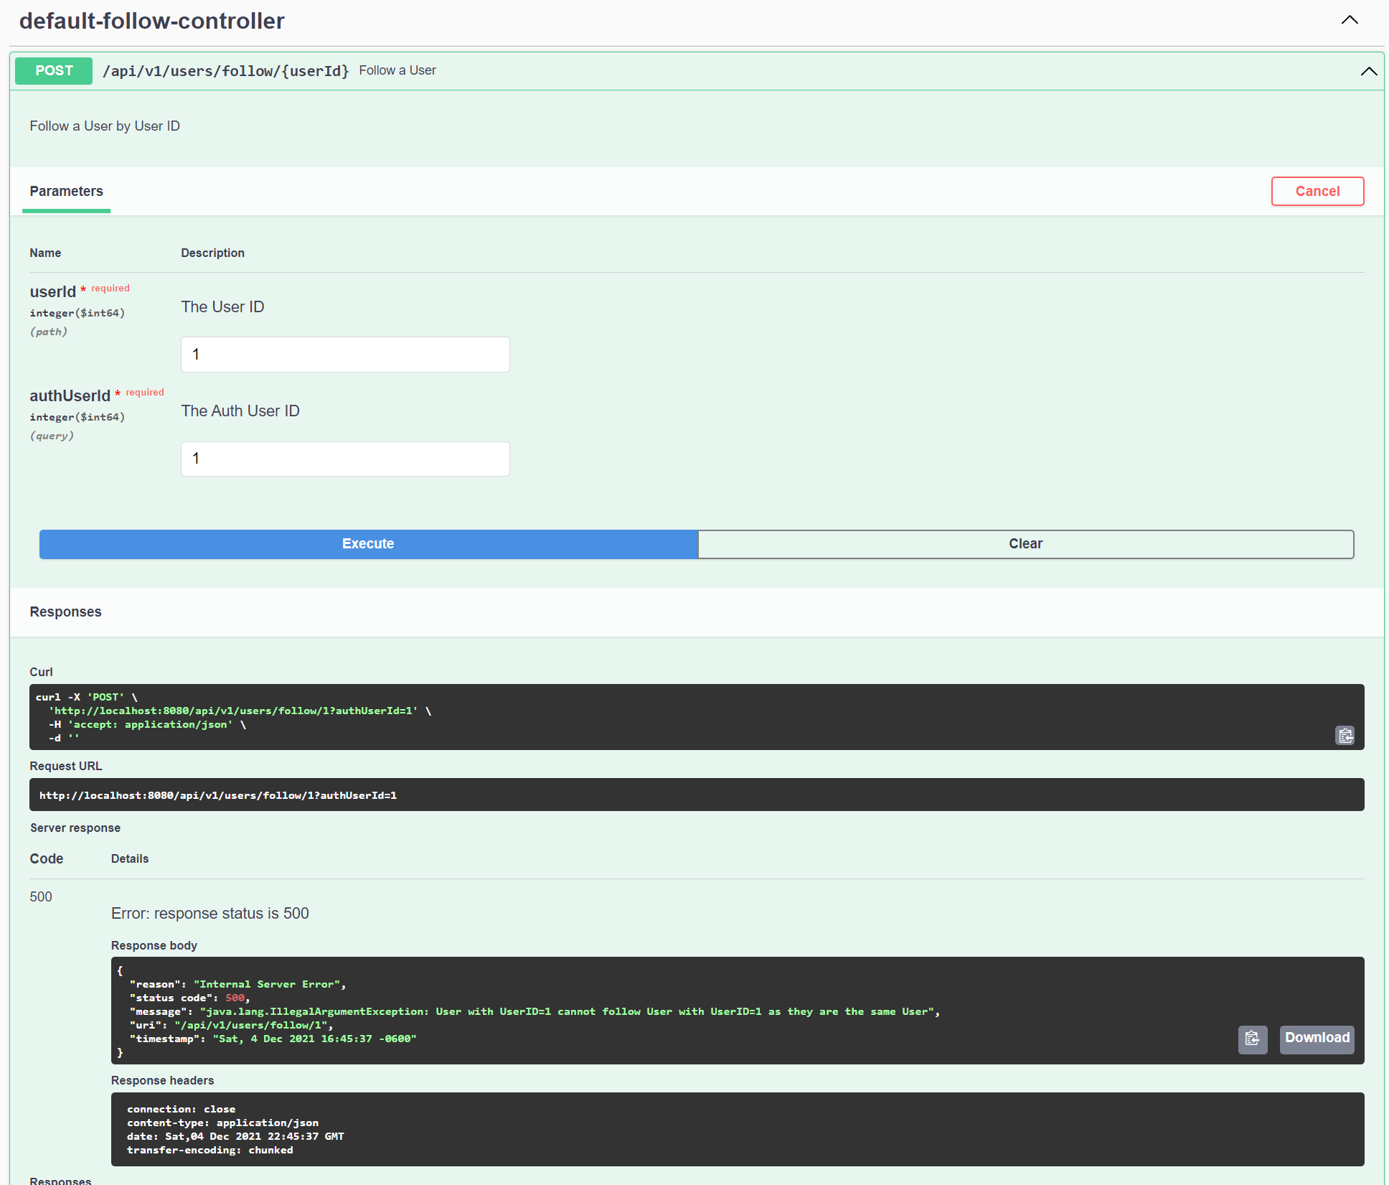

DATABASE TABLES

